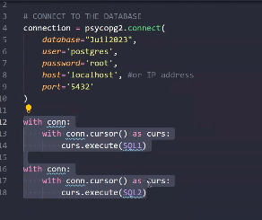import psycopg2

# CONNECT TO THE DATABASE

connection = psycopg2.connect(

database="Juil2023", #your database name

user='postgres',

password='root',

host='localhost', #or IP address

port='5432'

)

def retrieve_actors () :

try :

with connection:

with connection.cursor() as curs: #open and close the cursor

query = "SELECT * FROM actor"

curs.execute(query)

data = curs.fetchall()

print(data)

except Exception as err :

print(err)

retrieve_actors()

def retrieve_actors_numberoscars () :

try :

with connection:

with connection.cursor() as curs: #open and close the cursor

query = "SELECT number_oscars FROM actor"

curs.execute(query)

data = curs.fetchall()

print(data)

except Exception as err :

print(err)

retrieve_actors_numberoscars()

connection.close()